Ideation Phase
Define the Problem Statements

Date
Student ID | 23NU1A4221
Project Name | Metro ticket Generating system in ServiceNow
Maximum Marks | 2 Marks
Customer Problem Statements
PS-1: Long Waiting Time and Manual Ticket Booking
I am:
A metro passenger who uses metro services for daily or occasional travel.
I’m trying to:
Book a metro ticket quickly and conveniently by selecting my source, destination, passenger type, and number of tickets.
But:
I may have to wait in queues and spend extra time completing the ticket-booking process, especially during peak hours.
Because:
The ticket-booking process can involve multiple manual steps and dependence on station staff.
Which makes me feel like this:
Frustrated, delayed, and inconvenienced, especially when I am in a hurry.
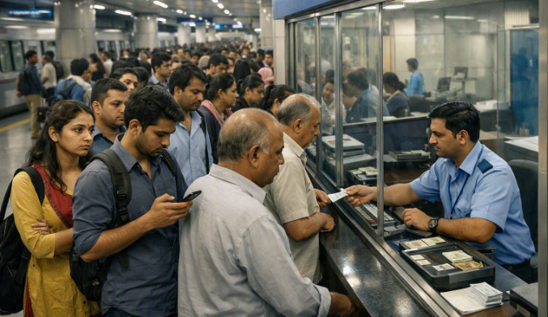
PS-2: Fare Calculation and Payment Inconvenience
I am:
A metro passenger who wants to complete my ticket purchase without unnecessary complications.
I’m trying to:
Know the correct fare for my journey and complete the payment conveniently.
But:
I may need assistance with fare calculation and may not have convenient payment options during the ticket-booking process.
Because:
Fare calculation and payment can involve manual processes or separate steps.
Which makes me feel like this:
Uncertain, inconvenienced, and concerned about delays or incorrect fare information.
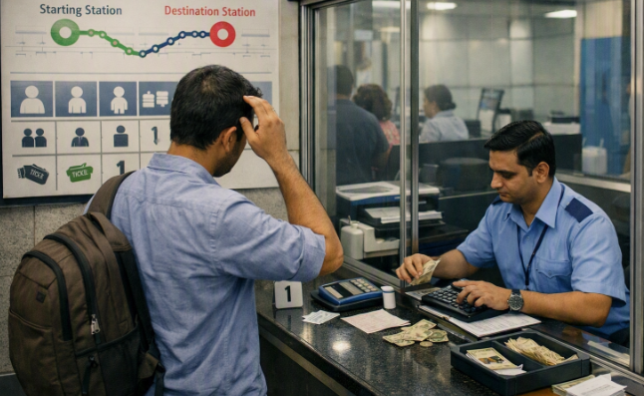

Final Problem Summary
Metro passengers may face long waiting times, manual ticket-booking steps, difficulty in determining the correct fare, and inconvenience during payment. These issues can lead to delays, confusion, and frustration, especially during peak hours. Therefore, there is a need for a simpler and more convenient ticket-booking process.

